Campus Connect – A Unified Platform for Student Engagement and Campus Security

A DESIGN THINKING PROJECT REPORT

Submitted by

Yuvana A |  | 23071A66D3
Bhanu Sree A |  | 23071A6902
Dhivya Prazna |  | 23071A6766
Rohan |  | 24075A1010

VALLURUPALLI NAGESWARA RAO VIGNANA JYOTHI
INSTITUTE OF ENGINEERING AND TECHNOLOGY
AICTEApproved;UGCAutonomous;JNTUHAffiliated;UGC“CollegewithPotentialforExcellence”;NAACA++”Grade
ISO 9001:2015 Certified; QS I.GAUGE “Diamond” Rated; NIRF 2020: 127thRank Engineering (151–200 Band Overall)
NBAAccredited:CE,CSE,ECE,EEE,EIE,IT,ME;JNTUH -RecognisedResearchCentres:CE,CSE,ECE,EEE,ME
Vignana Jyothi Nagar, Pragathi Nagar, Nizampet (S.O), Hyderabad TS 500 090 India
2024-2025

VALLURUPALLI NAGESWARA RAO VIGNANA JYOTHI
INSTITUTE OF ENGINEERING AND TECHNOLOGY
CENTRE FOR PRESENCING AND DESIGN THINKING
AICTEApproved;UGCAutonomous;JNTUHAffiliated;UGC“CollegewithPotentialforExcellence”;NAACA++”Grade
ISO 9001:2015 Certified; QS I.GAUGE “Diamond” Rated; NIRF 2020: 127thRank Engineering (151–200 Band Overall)
NBAAccredited:CE,CSE,ECE,EEE,EIE,IT,ME;JNTUH -RecognisedResearchCentres:CE,CSE,ECE,EEE,ME
Vignana Jyothi Nagar, Pragathi Nagar, Nizampet (S.O), Hyderabad TS 500 090 India

CERTIFICATE
This is to certify that the project titled “CAMPUS CONNECT” is being submitted, by Yuvana(23071A66D3, CSE-AIML), Bhanu Sree(23071A6902, CSE-IoT), Dhivya Prazna(23071A6766, CSE-DS) and Rohan(24075A1010, EIE) in partial fulfilment of the requirement for the award of degree of Bachelor of Technology to the Centre for Presencing and Design Thinking at the Vallurupalli Nageswara Rao Vignana Jyothi Institute of Engineering and Technology is a record of bona fide work carried out by them under our pedagogy. The results embodied in this Project have not been submitted to any other University or Institute for the award of any degree.
Project Mentor
Dr. Ch. Kiran
Associate Professor
Dept. of EIE
VNRVJIET
Hyderabad
Internal Examiners External Examiners

ABSTRACT

Colleges face challenges in managing student engagement and ensuring campus security, primarily due to outdated manual systems. Campus Connect aims to resolve these challenges by creating a centralized digital platform that integrates club registration, attendance tracking, and gate pass management. This project, grounded in the principles of Design Thinking, involves empathy-driven problem identification, ideation, prototyping, and iterative testing.
We initiated the process by conducting interviews with students, faculty, and security staff to understand their challenges. Through persona development and needs analysis, we identified key features to address primary, secondary, and latent needs. Brainstorming sessions led to a wide range of innovative solutions, from digital IDs to gamification. The prototype’s evaluation showed high desirability, feasibility, and viability. Additionally, the solution reduces environmental impact by digitizing manual tasks, reducing paper usage, and promoting accountability.
Campus Connect is a step toward modernizing campus life, offering a secure and engaging environment that aligns with the evolving needs of students and administration alike.

LITERATURE SURVEY
Modern educational institutions are increasingly shifting toward integrated digital platforms to manage academic and non-academic student activities. Several studies have explored the effectiveness of such systems in enhancing student engagement, reducing administrative burden, and improving campus safety. A review of existing systems reveals gaps in unified solutions that combine event participation, gate pass automation, and real-time engagement metrics. The following table summarizes recent research contributions in this domain:
S.No | Authors | Title of Paper | Methodology | Limitations | Research Gaps
1 | A. Gupta, R. Srinivasan, M. Desai (2021) | “Smart Campus: Automation in University Events and Security” | Developed a modular web app to track student club activities and gate pass movement. Conducted pilot at two engineering colleges. | Limited to club events; lacked integration with faculty dashboards and parental notifications. | Integration with administrative analytics and broader scalability remains unexplored.
2 | K. Sharma, T. Mehta (2022) | “Designing an IoT-Based Campus Entry System” | Deployed an RFID-based gate security system in a technical institute with live tracking. | Focused only on entry/exit; did not incorporate event participation or user profiles. | Absence of unified user experience for both engagement and security functions.
3 | P. Bansal, R. Iyer, S. Raj (2020) | “Gamification in Higher Education Portals: A UX Study” | User study involving 200 students across 3 colleges to evaluate gamified dashboards. | Did not cover institutional adoption or teacher usage. | Research needed on implementing gamification within extracurricular activity systems.
4 | V. Thomas, M. Rao (2019) | “Digital Attendance via QR: A Review of Existing Models” | Comparative study of QR-based attendance systems used in workshops and clubs. | Lacked centralized dashboard or club management features. | Need for integrated dashboards that combine attendance, profiles, and notifications.
5 | S. Singh, L. Kaur, R. Banerjee (2023) | “Unified Campus Management: Survey on Student-Admin Portals” | Surveyed 500+ students and 50 faculty across five Indian institutions on digital management systems. | Covered only academic modules (grades, fee payments). | Broader inclusion of extracurricular features like clubs, gate passes, and AI insights required.
TABLE OF CONTENTS
Details of Contents |  | Page no.
Abstract |  | iv
Literature Survey |  | v
Table of Contents |  | vi
List of Tables |  | vii
List of Figures |  | viii
Chapter 1: Introduction to Problem |  | 1
1.1 Objective |  | 1
1.2Outline |  | 2
1.3Motivation |  | 2
1.4Scope of the Project |  | 2
Chapter 2: Discover and Define |  | 3
2.1 Empathy Interview  2.2 Persona |  | 3
2.3User Needs |  | 4
Chapter 3: Customer service experience |  | 5
3.1 Service experience cycle |  | 5
3.2 Pain point address |  | 6
Chapter 4: Ideation |  | 7
4.1 Ideation Tools |  | 7
4.2 Outcome of Ideation Phase |  | 8
Chapter 5: Prototype model |  | 9
5.1 latent Needs Addressed |  | 9
5.2 Evaluation of prototype Based on Desirability, Feasibility& Viability |  | 11
Chapter 6: Conclusions and Future Scope |  | 13
6.1 Conclusions |  | 13
6.2 Future Scope |  | 13
References | 15
Appendix A: User Surveys |  | 15
A.1 Questionnaire for Users |  | 15
A.2 Text Transcripts of User Responses |  | 16

LIST OF TABLES
Details of Contents | Page no.
Table 3.2: Pain Points | 6
Table A.1: Questionnaire for Users  Table A.2: Text Transcripts of User Responses | 15  16

LIST OF FIGURES
Details of Contents | Page no.
Figure 5.1.1: Faculty Dashboard – Approvals and Clubs overview | 9
Figure 5.1.4: Student Dashboard – Club View, Event List, pass status | 10
Figure 5.2.1: Admin Dashboard – Analytics, Weekly Reports | 11
Figure 5.2.2: Landing Page – Campus Connect Overview | 12
Figure A.1: User Responses | 17

CHAPTER 1

INTRODUCTION
In today’s digitally-driven world, college campuses are still struggling with outdated manual systems to manage student engagement and campus mobility. Processes like club registrations, attendance tracking, and gate pass issuance are often scattered across paper forms, WhatsApp groups, and verbal approvals. These disconnected workflows not only waste time but also reduce student participation and compromise campus safety.
Campus Connect aims to bridge this gap by introducing a unified, smart platform that brings all student activity and movement-related processes under one roof. By digitizing key functions, the project envisions a campus experience that is more efficient, transparent, secure, and engaging for students, faculty, and administrators alike.
1.1 Objective
The primary objective of this project is to design and prototype Campus Connect—a comprehensive web-based platform that:
- Enables students to seamlessly register for clubs and events.
- Tracks event attendance through QR-code check-ins.
- Facilitates quick and secure gate pass requests and approvals.
- Empowers faculty, security personnel, and administrators with intuitive dashboards for monitoring participation and ensuring campus safety.
The goal is to make campus life smarter, more connected, and effortlessly manageable.
1.2 Outline
The project is structured around the Design Thinking process, which emphasizes empathy-driven problem-solving.
The major phases include:
- Empathize: Conduct interviews, surveys, and on-ground observations to deeply understand the pain points of students, staff, and security teams.
- Define: Identify key challenges such as fragmented communication, time-consuming approvals, and lack of participation data.
- Ideate: Generate innovative ideas using methods like brainstorming, mind mapping, and the SCAMPER technique.
- Prototype: Develop a functional model of the Campus Connect platform showcasing its core features.
- Test: Evaluate the feasibility, usability, and desirability of the solution through user feedback.
1.3 Motivation
This project is fueled by the real frustrations of students and staff alike. In our research:
- 86% of students reported missing club-related updates.
- 78% found gate pass procedures inconvenient and slow.
- Faculty and security staff expressed fatigue over inefficient and error-prone workflows.
We believe that a smarter, more centralized solution can not only save time but also encourage deeper student involvement, reduce faculty workload, and tighten campus security. The motivation lies in creating a digital ecosystem that simplifies operations and enhances the campus experience for everyone.
1.4 Scope of the Project
The scope of Campus Connect encompasses the design and development of a responsive web platform that includes:
- A student dashboard for club discovery, event registration, attendance tracking, and digital gate pass management.
- Faculty and security portals for managing approvals and verifying movement.
- An admin panel to oversee participation trends and campus movement analytics.
- Smart features such as notifications, event reminders, and participation history.
Future scope enhancements may include:
- A dedicated mobile app
- AI-driven club recommendations
- Integration with ERP systems
- Parental alert systems for movement tracking
The project is scalable and sustainable, aligning with modern campus digitization needs while offering a foundation for future innovation.

CHAPTER 2

Discover and Define
A critical component of the Campus Connect project was the application of the Design Thinking framework, beginning with a deep exploration into the real-world challenges faced by campus stakeholders. Through empathy-driven research, the team sought to uncover pain points, identify user’s behaviour, and define precise user needs. This chapter outlines the discovery process and how the insights shaped the foundation of the proposed solution.
2.1 Empathy Interviews
To develop a solution rooted in actual user experiences, structured interviews were conducted with key stakeholders across the campus environment. These included:
- 10 students representing various academic years and club involvements
- 4 faculty members responsible for student engagement and gate pass approvals
- 2 security personnel involved in campus movement verification
2.1.1 Interview Objectives:
- Understand how students currently engage with extracurricular activities.
- Examine the process and bottlenecks in gate pass approvals.
- Identify communication gaps and inefficiencies in current systems.
- Gather expectations and desired improvements from stakeholder.
2.1.2 Key Observations:
- A significant portion of students frequently miss out on club notifications due to fragmented communication platforms.
- The existing manual gate pass process is slow, error-prone, and lacks transparency.
- Faculty members experience an increased administrative burden when managing approvals.
- Security personnel have no effective means to verify the authenticity of paper-based passes.
2.2 User Persona
From the research insights, a representative user persona was developed to guide the design process and ensure user-centric decision-making.
- Name: Priya Sharma
- Age: 20
- Program: B. Tech, 2nd Year
- Personality Traits: Ambitious, proactive, digitally inclined
Involvement: Actively participates in student clubs and college events.
2.2.1 Pain Points:
- Often misses important announcements regarding events and club activities.
- The manual gate pass process is time-consuming and disrupts her schedule.
- Lacks a reliable method to track her extracurricular involvement, which she wishes to showcase in resumes and internship applications.
2.2.2 Goals:
To access a centralized digital platform for event registrations and gate pass requests and receive real-time notifications for events and approvals so as to maintain a comprehensive participation record for future use.
2.2.3 User Quote:
> “I just wish all club activities and gate passes were managed in one place on my phone.”
2.3 User Needs
Based on insights from interviews, surveys, and stakeholder observations, the core user needs were categorized into three distinct levels.
2.3.1 Primary Needs-
- Seamless digital registration for clubs and events.
- QR-based attendance tracking for accurate participation logging.
- Efficient and secure gate pass request and approval system.
2.3.2 Secondary Needs-
- Role-specific dashboards for faculty, coordinators, and security personnel.
- Comprehensive reports on student participation and gate pass activity.
- Automated alerts and reminders for upcoming events and approval statuses.
2.3.3 Latent Needs-
- Recognition mechanisms such as badges or leaderboard to encourage active participation.
- Parental notifications for approved gate pass activities to enhance safety.
- AI-driven recommendations for clubs or events based on interests and past participation.

CHAPTER 3

Customer service experience
A successful digital solution must align with the end-to-end journey of its users. Campus Connect was designed with a focus on delivering a seamless, efficient, and value-driven experience for students, faculty, and administrative personnel. This chapter outlines the complete Service Experience Cycle and illustrates how the platform effectively addresses the core pain points identified during the discovery phase.
3.1 Service Experience Cycle
The Service Experience Cycle maps the user journey across various stages of interaction with the system. It ensures that every touchpoint—from discovery to resolution—is optimized for clarity, speed, and user satisfaction.
3.1.1. Discovery
- Users (primarily students) become aware of club activities or events through push notifications or browsing the dashboard.
- Clubs and events are recommended based on the user's past participation and interests (future AI-enabled feature).
3.1.2. Engagement & Registration
- Students register for events or clubs with a single click.
- All activities are added to a personal calendar with automated reminders.
3.1.3. Attendance & Participation
- Students check in to events using QR code scanning.
- Attendance is logged instantly and added to their participation profile.
3.1.4. Gate Pass Request
- Students request gate passes through the portal, specifying destination, time, and purpose.
- Faculty receive instant notifications for approval with just one click.
3.1.5. Security Verification
- Security personnel scan QR codes at the gate to validate gate passes.
- Real-time verification ensures movement tracking without delays or forgery.
3.1.6. Feedback & Recordkeeping
- Students can view and export participation history.
- Faculty and admins can generate analytics reports on engagement trends.
- Optional: Parental alerts and gamification feedback (e.g., badges, leaderboards).
3.2 Pain Point Address
The Campus Connect platform was explicitly designed to resolve the pain points identified through stakeholder interviews and surveys. The following table summarizes how the system addresses each issue:
Stakeholder | Pain Point | Campus Connect Solution
Students | Missed event updates due to fragmented communication | Centralized notification system and personalized dashboard
 | Delays and inconvenience in manual gate pass processes | Instant digital gate pass request and approval system with QR verification
 | No tracking of participation for internships or extracurricular records | Automated event-wise attendance logging and downloadable participation reports
Faculty | High workload managing paper-based approvals | One-click digital approval interface with logs
 | No visibility into student involvement | Access to detailed analytics and participation trends
Security Staff | Inability to verify authenticity of paper gate passes | QR-code based scanning for real-time gate pass verification
Administrators | Lack of data on student engagement and campus movement | Comprehensive dashboards with filters, trends, and download options

Table 3.2 Pain Points

CHAPTER 4

Ideation
The ideation phase marks a turning point in the Design Thinking process where creative thinking is harnessed to generate potential solutions grounded in user insights
To ensure structured creativity, our team adopted multiple ideation tools that encouraged both divergent and convergent thinking. This allowed us to explore a wide range of ideas before narrowing down to the most impactful and feasible solutions.
4.1 Ideation Methods and Tools
4.1.1. Brainstorming:
We initiated the ideation process with open brainstorming sessions. These encouraged every team member to freely contribute without criticism. The outcome was over 50 raw ideas related to communication, club engagement, attendance, security, and digital verification. These ideas were later grouped into thematic clusters for deeper exploration.
4.1.2. Mind Mapping:
Mind maps helped us visually organize the relationship between core user needs and technical possibilities. This tool allowed us to identify features such as real-time event alerts, a unified dashboard, and secure gate pass workflows.
4.1.3. SCAMPER Technique:
We applied SCAMPER (Substitute, Combine, Adapt, Modify, Put to another use, Eliminate, Reverse) to refine our early concepts. For example:
- Substituted manual gate passes with QR-based digital ones
- Combined event registration and attendance into a single process
- Eliminated redundant paper-based approvals
- Modified attendance validation using mobile devices for ease and speed
4.1.4. Three-Box Thinking:
This method allowed us to approach problems from three angles:
- Forget the past: Removed outdated systems such as paper records
- Manage the present: Identified urgent needs like digital approval processes
- Create the future: Envisioned features like AI club suggestions, gamification, and real-time monitoring for administrators
4.1.5. Role-Based Feature Mapping
We carefully mapped features based on the needs of four main user roles:
- Students: A personalized dashboard for club registration, QR check-ins, and gate pass requests.
- Faculty: Quick access to approval workflows and event participation records.
- Security: QR scanning for instant validation.
- Administrators: Analytics dashboard with reports on student engagement and movement trends.
4.2 Outcome of the Ideation Phase
As a result of this structured ideation process, we conceptualized Campus Connect — a centralized, web-based platform designed to streamline extracurricular engagement and campus movement management. The platform was envisioned to be scalable, mobile-responsive, and compatible with existing institutional systems.
Key outcomes include:
Platform Architecture-
A modular design consisting of:
- Student portal for event registration, attendance, and gate passes
- Faculty dashboard for approvals and monitoring
- Security interface with QR verification tools
- Admin dashboard with participation analytics and reports
Feature Prioritization-
We divided features into three tiers to guide development:
- Core MVP: Digital gate pass system, event registration, attendance tracking, and dashboards
- Secondary: Gamification (badges, leaderboards), auto-generated reports, and reminders
- Future Scope: AI recommendations, parental alerts, academic integration, digital certificates
Value Propositions by Role-
- Students gain transparency, convenience, and a verifiable extracurricular record
- Faculty benefit from reduced administrative burden
- Security achieves faster and more reliable gate validation
- Administrators gain access to data-driven decision-making tools
Design Philosophy- We committed to a clean, minimal UI; guided workflows for all users; and inclusive design with support for multilingual access and basic accessibility features and to integrate with future tools like Learning Management Systems (LMS) and internship tracking portals.

CHAPTER 5

Prototype model
The prototype phase of the Campus Connect project marks a pivotal stage in transforming conceptual ideas into a tangible, testable model. Based on insights from the empathy and ideation phases, our team designed a digital prototype that reflects the real-time needs of students, faculty, and administrative staff.
This high-fidelity, role-specific prototype captures the platform’s core functionalities—club registration, attendance tracking, and gate pass approvals.
5.1 Latent Needs Addressed
In addition to solving visible, expressed challenges, the prototype also targets several latent (unspoken or indirect) needs that emerged during user research. These needs were addressed through design choices and forward-thinking features, elevating the platform from a task-oriented system to a meaningful digital experience.
5.1.1 Role-Based Personalization-
Users interact with different interfaces based on their roles. For instance:
- Students can view club memberships, upcoming meetings, and request gate passes.
- Faculty can approve gate pass requests, manage advised clubs, and track event involvement.
- Admins have access to data dashboards showing student participation, gate pass analytics, and club activity.
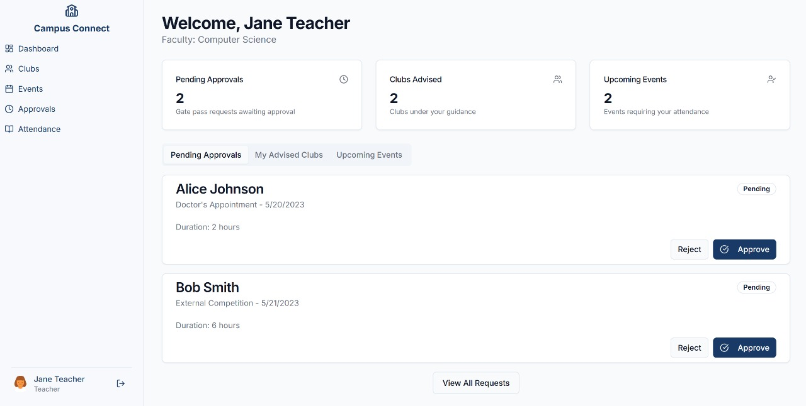
Fig 5.1.1 Faculty Dashboard – Approvals and Clubs overview
5.1.2 Time-Saving Automation-
Tasks like gate pass approval and attendance logging are reduced to one-click actions. This automation reduces cognitive load for faculty and speeds up administrative workflows.
5.1.3 User Empowerment and Transparency-
Students can view their event history and track the status of their gate passes, encouraging ownership and accountability.
5.1.4 Scalable Design for Future Features-
Though not implemented in the current build, the architecture allows for seamless integration of Gamified features (badges, leaderboards), AI-based club suggestions based on past participation, Parental notifications for approved movement requests
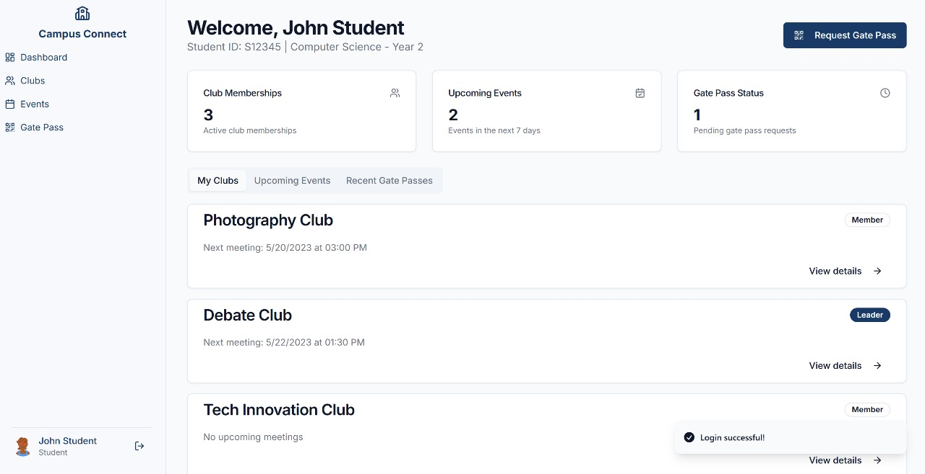
Fig 5.1.4 Student Dashboard – Club View, Event List, Gate Pass Status

5.1.5 Security and Trust-
QR code-based gate passes enhance security by eliminating forgery-prone paper slips. Faculty can quickly approve or reject requests, and security staff can verify authenticity with a scan.

5.2 Evaluation Based on Desirability, Feasibility & Viability
To assess the effectiveness and practicality of the prototype, we applied the Real-Win-Worth model—focusing on three critical aspects: desirability, feasibility, and viability.

- Desirability – Is the platform wanted by users?
The prototype was evaluated by a sample group of students, faculty, and admin personnel. The majority of users found the interface intuitive, visually appealing, and tailored to their needs, clean, role-specific dashboards with minimal learning curve, Immediate access to relevant information (events, passes, club data), Smooth navigation between modules.
Feedback Highlights:
- "The QR gate pass feature saves so much time." – Faculty Member
- "I finally know when and where club meetings are." – Student User

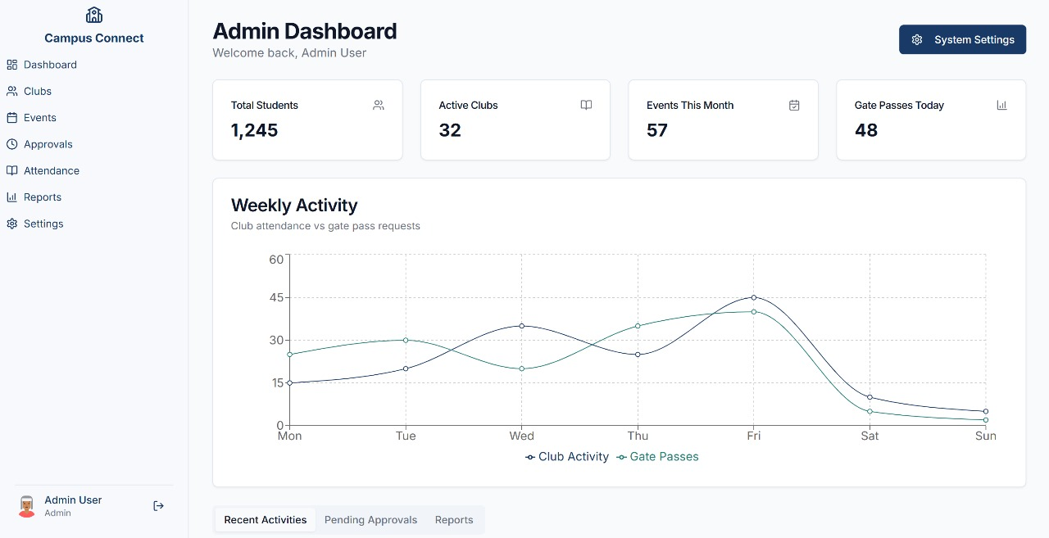
Fig 5.2.1 Admin Dashboard – Analytics, Weekly Reports

Conclusion: Highly desirable. The system aligns with user preferences and solves high-friction problems efficiently.

- Feasibility – Can the prototype be realistically developed and deployed?
The prototype is feasible to implement using web-based technologies:
- Frontend: React.js or Vue.js for dynamic user interfaces
- Backend: Node.js with Firebase or MongoDB for real-time databases
- Security: JWT-based authentication with QR code verification
- Deployment: Easily hosted on cloud platforms like Vercel (frontend) and Render or Firebase (backend)
Conclusion: Technically feasible with moderate development resources and accessible toolsets.

- Viability – Is the system sustainable and scalable in the long term?
The solution offers measurable institutional benefits:
- Reduces paperwork and manual communication
- Provides analytics for administrative insights
- Improves student engagement, which may reflect positively on accreditation and rankings
- Scalable for other departments or institutions, potentially monetizable as an EdTech solution
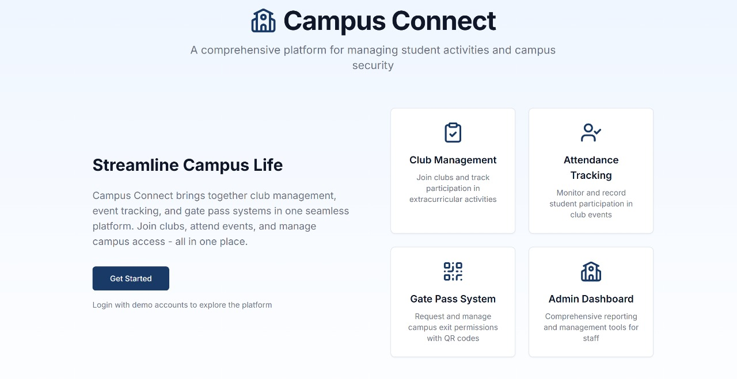
Fig 5.2.2 Landing Page – Campus Connect Overview (Club Management, Gate Pass, Reports)
Conclusion: Viable for both institutional adoption and future expansion.

CHAPTER 6

Conclusions and Future Scope

6.1 Conclusions
The design and development of the Campus Connect platform has demonstrated the potential of user-centred innovation in addressing longstanding inefficiencies in student engagement and campus movement management. Through a structured application of the Design Thinking methodology—including empathy research, persona creation, problem definition, ideation, and prototyping—the team was able to identify critical pain points experienced by students, faculty, and administrators.
The prototype successfully integrates essential features such as digital club registration, event attendance tracking, and QR code-based gate pass management within a single cohesive system. By addressing both explicit user demands and latent experiential needs—such as gamification, parental notifications, and AI-based club suggestions—the solution not only improves operational efficiency but also enhances student participation, accountability, and institutional transparency.
In essence, Campus Connect is more than a digital tool; it is a foundational step towards building smarter, safer, and more connected academic communities.
6.2 Future Scope
While the current prototype addresses the core functionality required for a digital student engagement and campus access system, there are numerous opportunities for future enhancement and scalability:
- Mobile App Development: Transitioning the platform into a dedicated mobile application for Android and iOS would increase accessibility and improve real-time interaction.

- Integration with Biometric/Smart ID Systems: For enhanced security and automation, the system can be expanded to incorporate biometric verification or smart card integration at entry/exit points.

- Advanced Analytics Dashboard: Implementing data visualization tools and predictive analytics would allow institutions to track trends in student engagement, identify at-risk individuals, and optimize resource allocation.

- Multi-Institutional Deployment: The platform can be adapted for use across multiple colleges or universities, offering a centralized solution for educational networks or consortiums.
- Third-Party API Integration: Future versions may support integration with tools such as Google Calendar, WhatsApp notifications, ERP systems, or Learning Management Systems (LMS).

- Accessibility & Inclusivity Features: Adding voice navigation, multilingual support, and accessibility settings will ensure the platform remains inclusive to students with diverse needs.

- Through continued refinement and stakeholder collaboration, Campus Connect holds strong promise for transforming institutional engagement models and setting new standards in digital campus management.

REFERENCES
- Books: • Brown, T. (2009). Change by Design: How Design Thinking Creates New Alternatives for Business and Society. HarperBusiness.
- Research Papers: • Deterding, S., Dixon, D., Khaled, R., & Nacke, L. (2011). "From Game Design Elements to Gamefulness: Defining 'Gamification'." In Proceedings of the 15th International Academic MindTrek Conference, pp. 9–15. Link • Khan, M. A., Mahmood, A., Safdar, A., Khan, Z. A., & Khan, N. A. (2016). "Load forecasting, energy storage, and smart meters for smart grid: A review." Renewable and Sustainable Energy Reviews, 68, 165–177.
- Standards: • ISO 50001:2018 – Energy Management Systems – Requirements with Guidance for Use.
- Web Resources: • U.S. Department of Energy. Smart Grid Initiatives and Energy Efficiency. Available at: https://www.energy.gov • EDUCAUSE Review (2020). "Students' Preferences in Campus Tech Systems." Available at: https://er.educause.edu • Capterra. (2021). "Top Campus Management Software Systems." Available at: https://www.capterra.com
APPENDIX
Section | Question | Options/Type
General Information | What is your age group? | a. Under 18 b. 18–25 c. 26–40 d. 41–60 e. Over 60
 | Where do you primarily manage energy consumption? | a. Home b. Workplace c. Both
Current Practices | How do you currently track or manage your energy usage? | Open-ended
Digital Platform Experience | Are you familiar with using digital platforms or apps for tracking tasks? | a. Yes b. No
 | Have you used any campus management app or software before? | a. Yes b. No c. Not sure
Participation Frequency | How frequently do you attend club/extracurricular activities? | a. Very Frequently b. Occasionally c. Rarely d. Never
Communication Channels | How do you receive updates about club events or gate passes? | a. WhatsApp b. Word of Mouth c. Emails d. Notices e. None
Feature Preferences | Would you prefer a centralized app to manage clubs and gate passes? | a. Yes b. Maybe c. No
 | What additional features would improve your experience? | Open-ended

Fig A.1 Questionnaire for Users
Respondent Role | Feedback
Student | "I often miss club events because announcements are made too late or never reach me."
Student | "Gate pass approvals take too long; sometimes they get misplaced."
Student | "A single platform would make it easier to stay engaged without juggling multiple apps."
Faculty | "Manual attendance is inefficient. We need digital records that are accessible instantly."
Faculty | "Approving passes during lectures is distracting. A streamlined system would help."
Security Staff | "Paper gate passes are easy to forge. QR codes or app-based verification is much better."
Security Staff | "Sometimes we have no idea whether a pass is valid unless we confirm by calling staff."

Fig A.2 Text Transcripts of User Responses
These responses shaped our understanding of user needs and informed our design decisions during the empathy and prototyping stages.

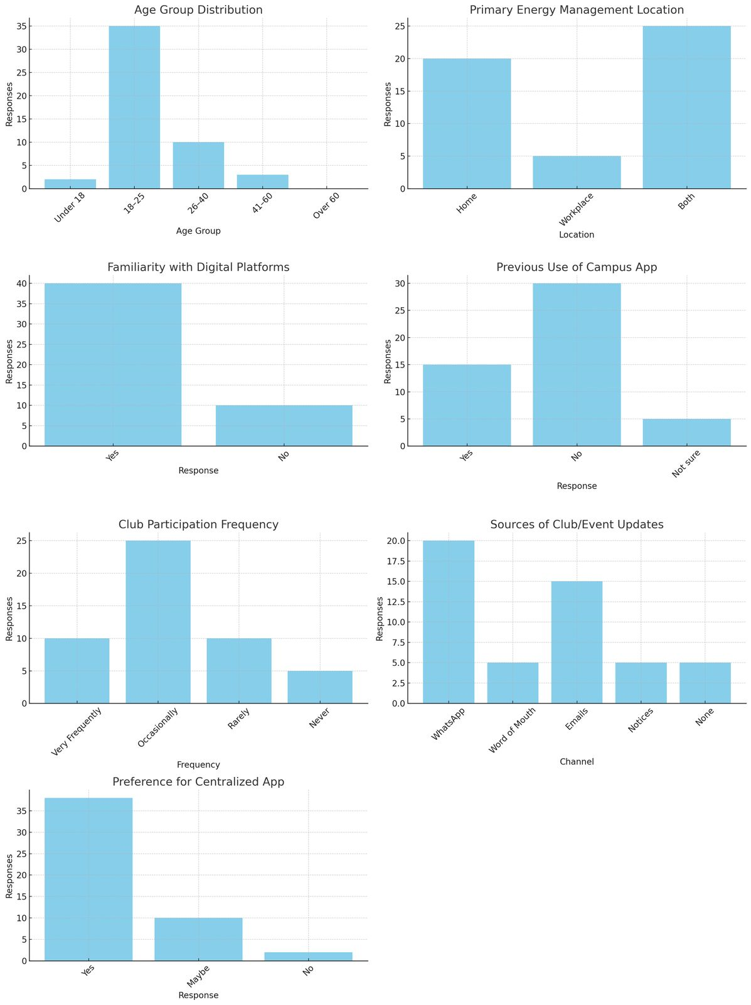

Fig A.1: User Responses

